NOTE:
- Submit latest STP from IPPS-A. Redact your photo, gender, race, and ethnic group. STP must include your GT score and line scores. Front and back page of STP is required.
- ONLY REDACT PHOTO, GENDER, RACE, AND ETHNIC GROUP
- ALL STP WILL BE OF THE HIGHEST LEGIBILITY OR SUBJECT TO APPLICATION BEING RETURNED WITHOUT ACTION
- ALL APPLICATIONS WILL CONTAIN STP FRONT PAGE AND BACK PAGE
https://my.ippsa.army.mil/
- OPEN IPPS-A
- SELECT “MY SOLDIER TALENT PROFILE”
- CLICK “PRINT” AT THE TOP RIGHT
- ENSURE PRINTER IS “MICROSOFT PRINT TO PDF”
- SELECT “PRINT”
- SAVE THE FILE TO YOUR DESKTOP

ONCE THE FILE IS SAVED TO YOUR DESKTOP PROCEED TO STEP 7

- NOW OPEN THE FILE (YOUR STP) THAT YOU JUST SAVED TO YOUR DESKTOP
- MAKE SURE THAT YOU ARE OPENING YOUR STP FILE IN ADOBE ACROBAT
- SELECT “EDIT PDF”  ON THE RIGHT SIDE OF YOUR SCREEN IN ADOBE
- USE THIS BLACK BOX TO COVER (REDACT) YOUR PHOTO, GENDER, RACE, AND ETHNIC GROUP ON PAGE 1 AND 2
- YOU CAN COPY THAT BLACK BOX AND PASTE ON YOUR STP TO KEEP YOUR STP IN A HIGHER QUALITY OF RESOLUTION
- DO NOT REDACT ANY OTHER ADDITIONAL SECTIONS FROM YOUR STP
- SAVE AFTER YOU HAVE MADE YOU EDITS

BELOW ARE SCREENSHOTS TO GUIDE YOU

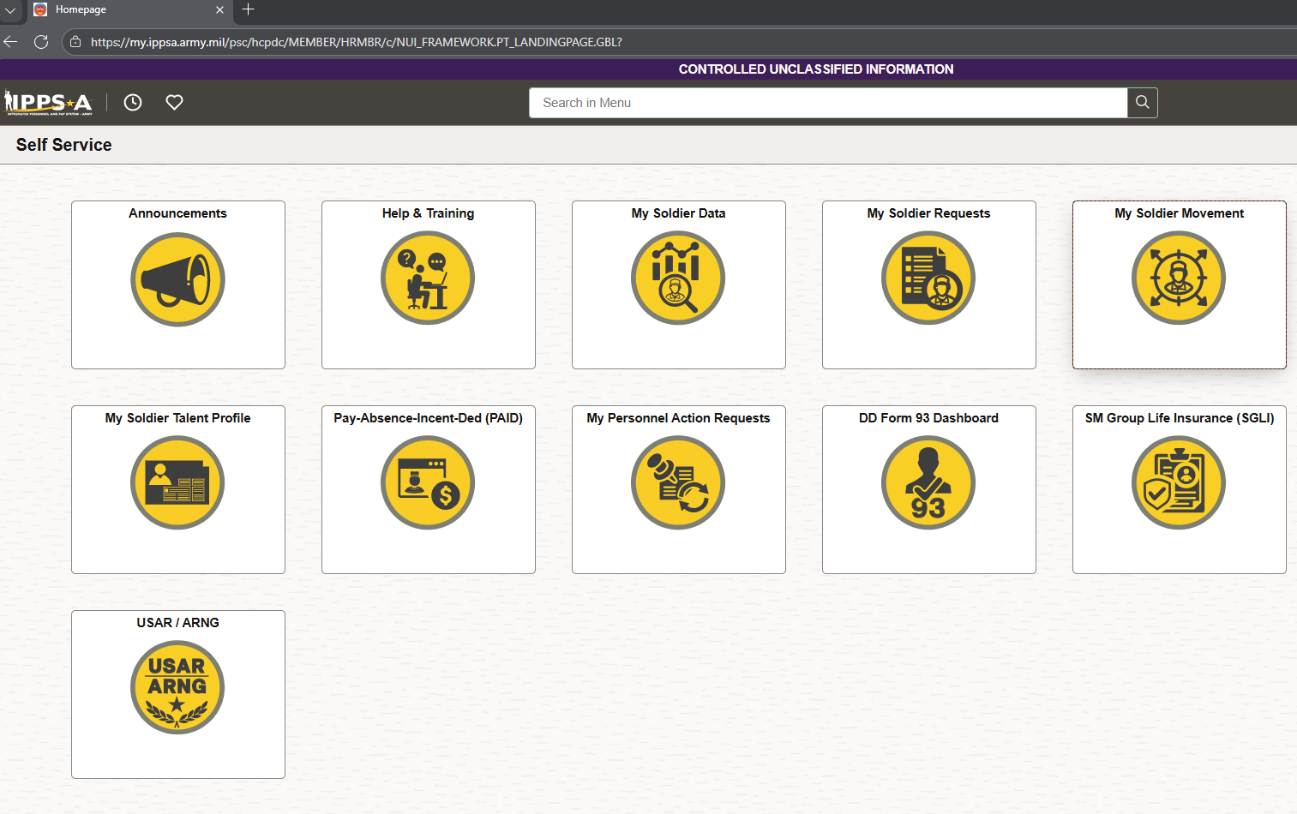
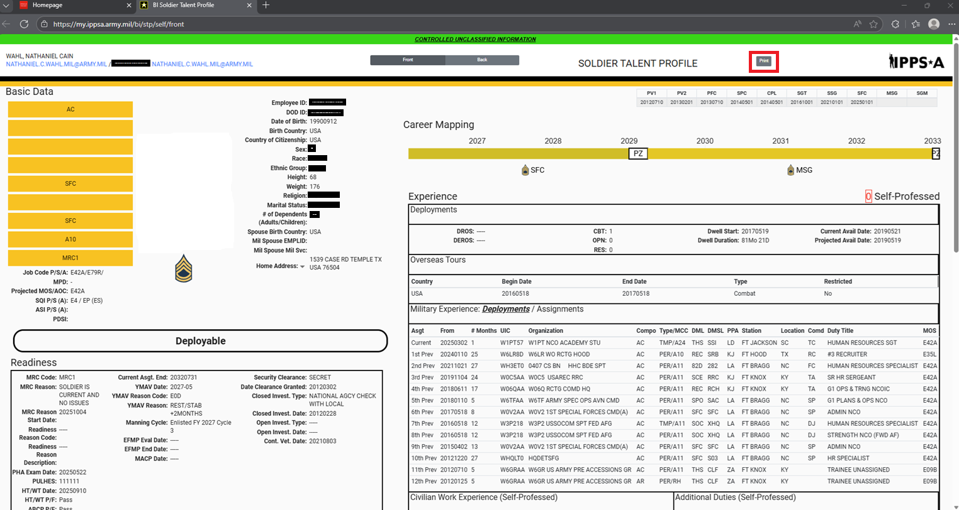

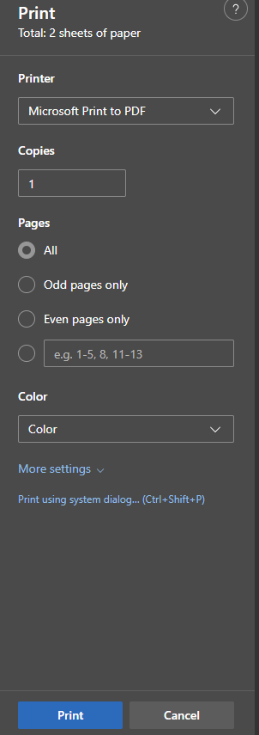
THIS IS HOW YOUR STP FRONT PAGE WILL LOOK