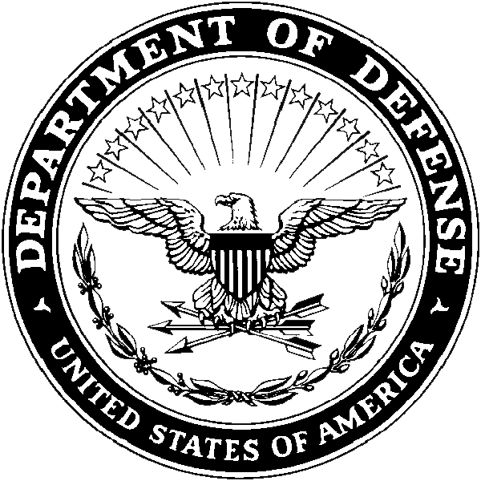
Department of the Army
- Headquarters, USAREC (RCHS-SVD-PA)
- 1307 Third Avenue
- Fort Knox, KY 40121-2726

RCHS-SVD-PA Current Date (after 1 June 2020)

MEMORANDUM FOR COMMANDER, HQ USAREC ATTN: RCHS-SVD-PA 1307 Third Avenue, Fort Knox, KY 40121-2726

FOR Staff Sergeant Jane Q Doe, U.S. Army Medical Department Activity, Fort Jackson, SC 29207

SUBJECT: Height and Weight Verification Memo

1. I verify the above mentioned Service Member is within the Army body composition standards in accordance with AR 600-9. Their height and weight were measured on Insert Date. Their height was XX inches and weight was XX pounds. The Service Member did/did not require completion of the body fat worksheet. (If required please include calculated body fat percentage and worksheet.)

2. I can be reached at DSN 123-4567, commercial (123) 456-7890, or e-mail JaneQDoe@us.army.mil.

CDR/1SG Signature block
CPT, SP
Commanding

