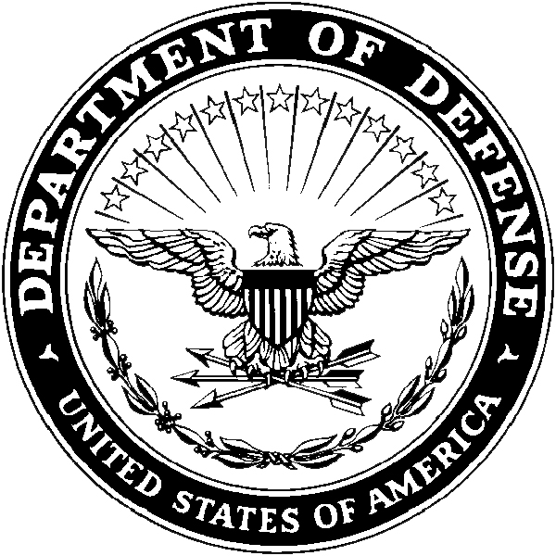
Department of the Army
- Headquarters, USARD (RCHS-SVD-PA)
- 1307 Third Avenue
- Fort Knox, KY 40121-2726

RCHS-SVD-PA Current Date

MEMORANDUM FOR COMMANDER, HQ USARD ATTN: RCHS-SVD-PA 1307 Third Avenue, Fort Knox, KY 40121-2726

FOR Staff Sergeant Jane Q Doe, U.S. Army Medical Department Activity, Fort Jackson, SC 29207

SUBJECT: Interservice Physician Assistant Program Application Conviction Waiver Request

1. In accordance with AR 601-20, 135-100 and AR 135-101 I request a waiver for an Article 15 I received in Basic TRNG.(*Add all of the details – the more detail, the better chance of approval). I received the Article 15 for….. I have not received any negative Uniform Code of Military Justice (UCMJ) actions since the above mentioned Article 15.I haven’t been in trouble since then >>>

2. Supporting legal documents are attached.

3. I can be reached at DSN 123-4567, commercial (123) 456-7890, or e-mail JaneQDoe.mil@mail.mil.

JANE Q DOE
SSG, USA
Combat Medic

