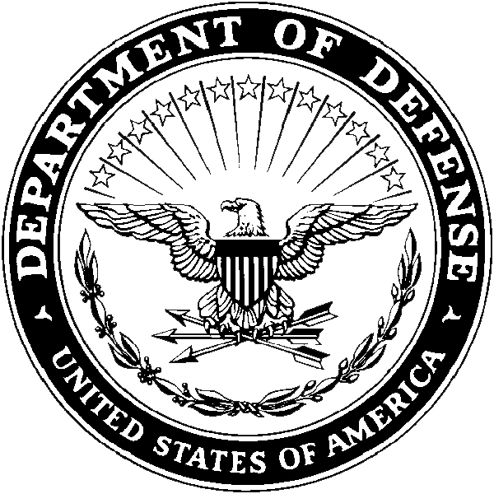
Department of the Army
- Headquarters, USAREC (RCHS-SVD-PA)
- 1307 Third Avenue
- Fort Knox, KY 40121-2726

RCHS-SVD-PA XX January 2020

MEMORANDUM FOR Commander, USAREC, RCHS-SVD, 1307 Third Avenue, Fort Knox, KY 40121-2726

SUBJECT: Request for Academic Delay for Fiscal Year (FY) 2020 Interservice Physician Assistant Program (IPAP) application

1. I, SGT John Doe, 123-45-6789, am requesting academic delay for the FY 20 IPAP application. The following list of remaining courses (no more than 9 SH) will be completed NLT 31 DEC 20, or I will forfeit my IPAP selection. I understand that I must maintain a cumulative GPA of 2.5 and science GPA of 3.0, and at least attain a C in the class, IAW AR 601-20 and MILPER 19-221.

Course College Start Date End Date
a. Anatomy and Physiology I UNMC 5/29/2018 7/15/2018
b. Anatomy and Physiology II UNMC 7/29/2018 9/15/2018
c. Chemistry I UNMC 5/5/2018 7/22/2018
d. Chemistry II UNMC 9/7/2018 11/24/2018

2. POC for this action is the undersigned at (123) 456-7890

John Doe
SGT, USA
TMC NCO

