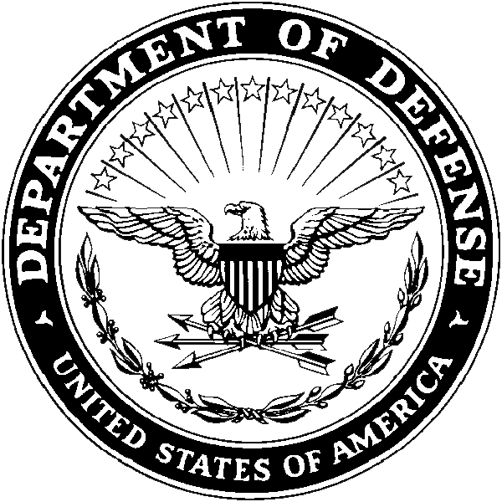 Department of the Army

Headquarters, USAREC (RCHS-SVD-PA)

1307 Third Avenue

Fort Knox, KY 40121-2726

RCHS-SVD-PA XX XXX 2020

MEMORANDUM FOR Commander, USAREC, RCHS-SVD, 1307 Third Avenue, Fort Knox, KY 40121-2726

SUBJECT: Request for Academic Delay for Fiscal Year (FY) 2023 Interservice Physician Assistant Program (IPAP) application

1. I, SGT John Doe, am requesting academic delay for the FY 23 IPAP application. The following list of remaining courses (no more than 9 SH) will be completed NLT 1OCT23, or I will forfeit my IPAP selection. I understand that I must maintain a cumulative GPA of 2.5 and science GPA of 3.0, and at least attain a C in the class, IAW AR 601-20 and the FY23 IPAP MILPER.

Course College Start Date End Date

a. Anatomy and Physiology I UNMC 5/29/2020 7/15/2020

b. Anatomy and Physiology II UNMC 7/29/2020 9/15/2020

c. Chemistry I UNMC 5/5/2020 7/22/2020

2. POC for this action is the undersigned at (123) 456-7890.

John Doe

SGT, USA

TMC NCO